Unity Tutorial By: Patrick Ebeling

1. First load the application “Unity”.
2. Upon loading you will have to create a new project. To do so, click “File->New Project.”

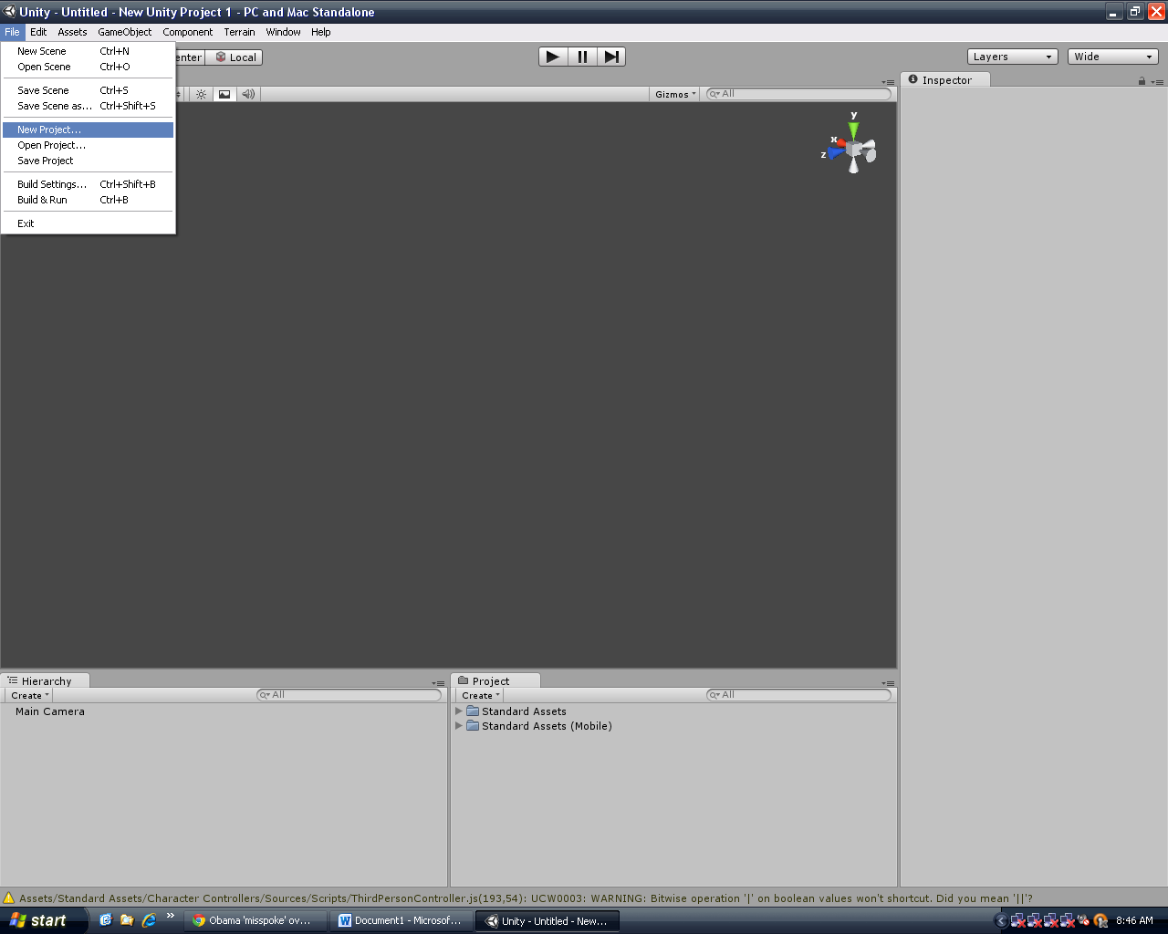

1. Choose a destination on your H:/ Drive.
2. Remember to check the boxes for all the imports so that you have those resources before you click create.
3. Now it’s time to create your land :D Now click “Terrain->Create Terrain”  
   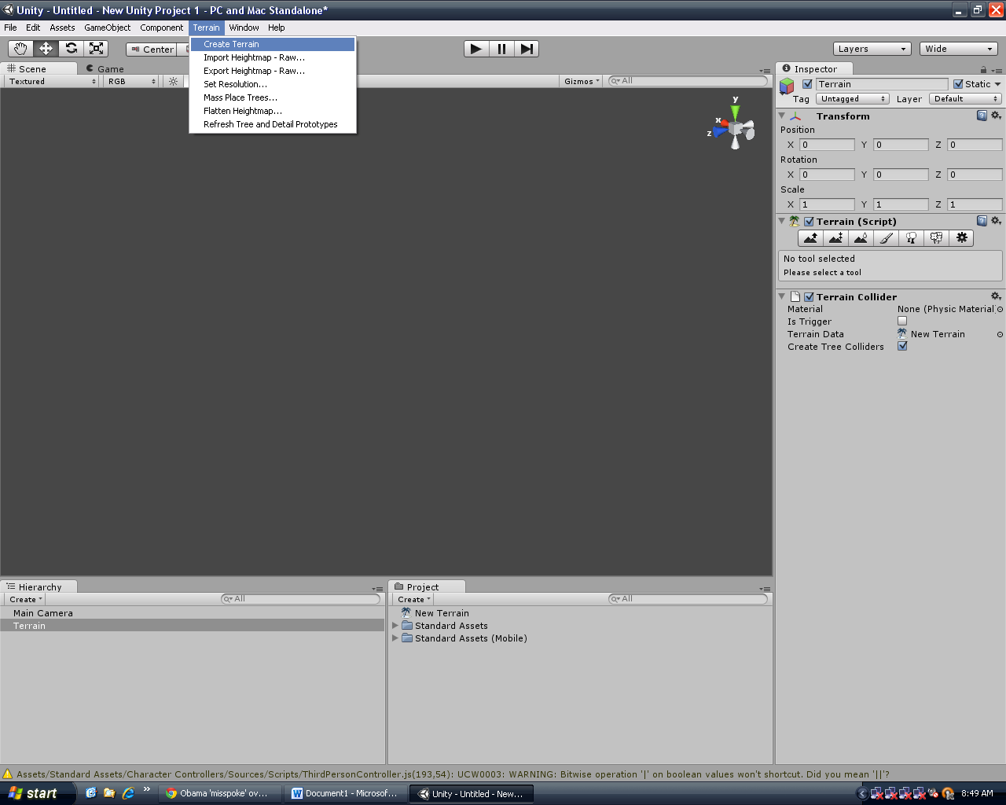
4. Now we have got land….But we need a sky to make it full. Now Click “Edit->Render Settings” 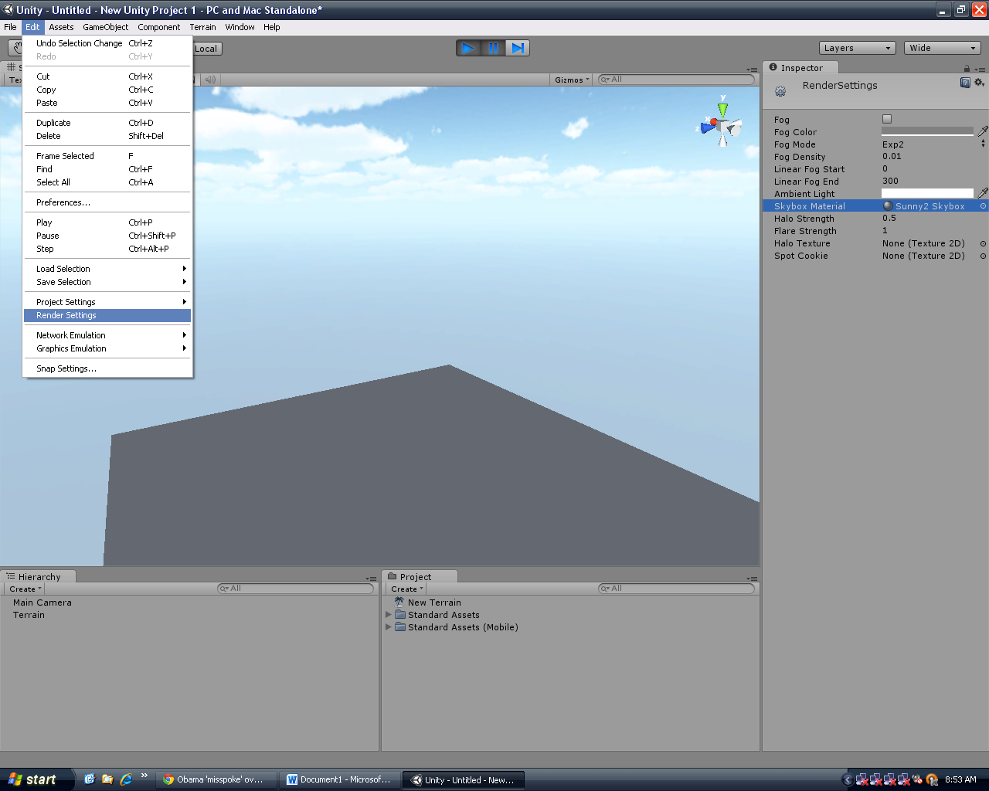
5. Now in the inspector click “Skybox Material” and choose a material you would like. I suggest the “Sunny2” Skybox.

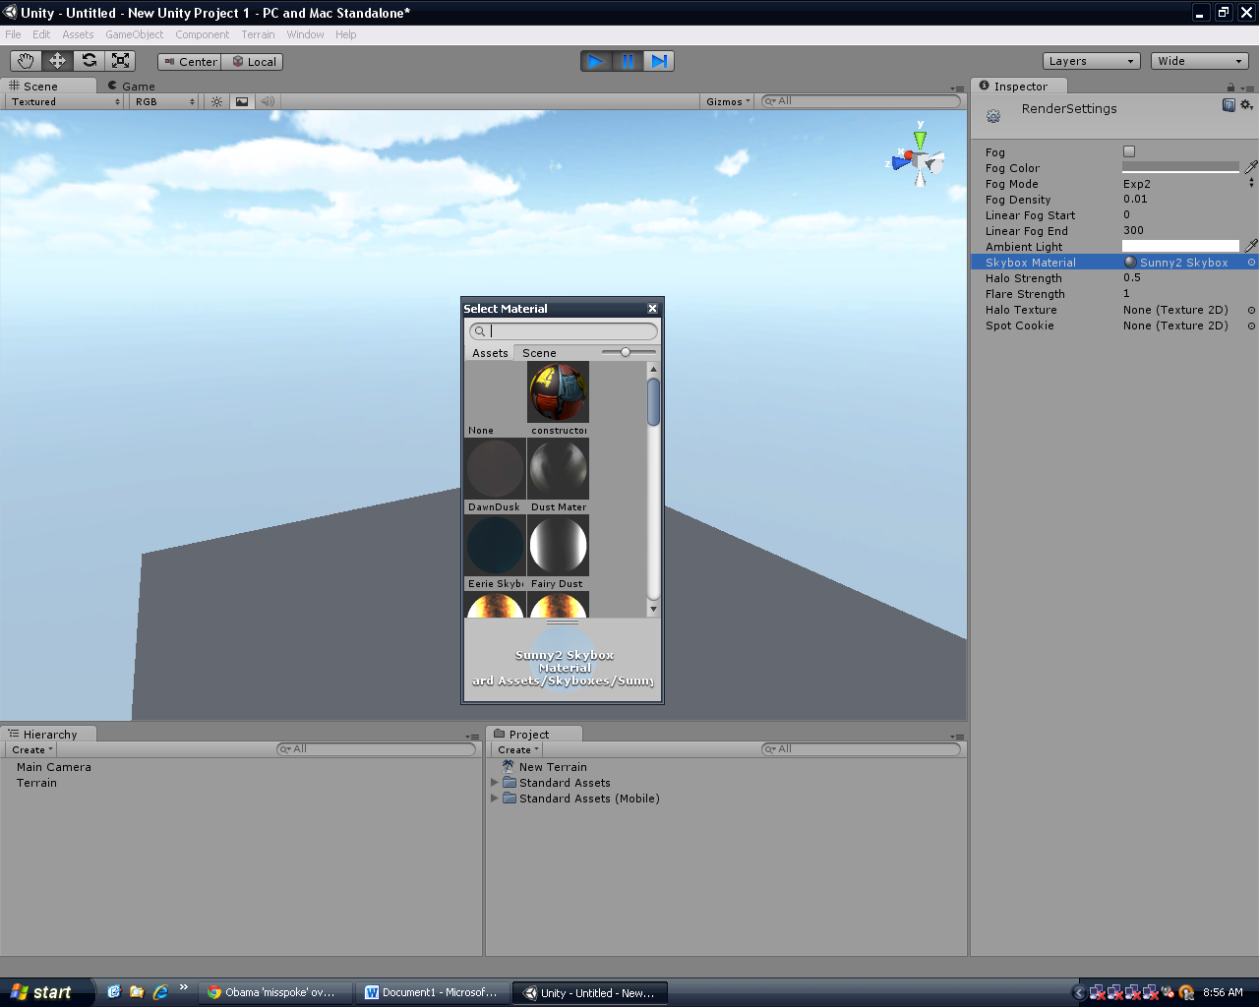

1. Now to build some terrain…Click back on the terrain in the Hierarchy.
2. After doing so look in the inspector. There should be several buttons to click on in the “Terrain” section. We are going to click on the first one and choose the large circle brush. 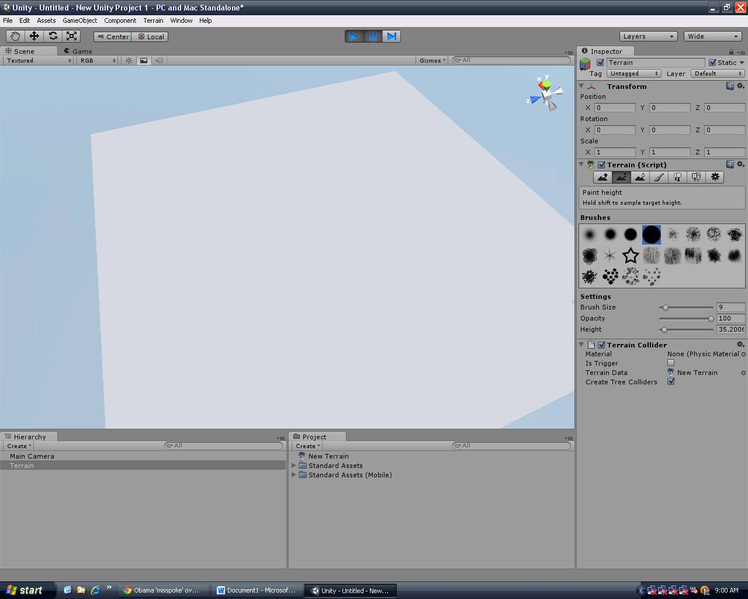



1. Now go crazy with the tool all over the terrain! Get used to the tool because this will be how you will create the land.
2. Congratulations! You have created a basic terrain and sky with Unity!
3. For more help go the unity website at Unity3d.com